**Matthew Austin**

**Assignment 1**

**CIS356** – Spring Term 2018

**Point Value**: 100 points

**Assignment Due Date**: **Thursday, January 25, 2018**

**Submission Instruction**

Please write the solution to the questions in a Microsoft Word document. You can use screenshots to show the results of a command. Please submit your solution to Schoology by 11:59pm January 25 and demonstrate your solutions to your instructor in class on the due date or before.

**Description**

Activate your AWS account and create an instance with Ubuntu 16.04 server AMI. Start the instance, connect to the instance using SSH or Putty **(30 points)**, and then run the following command:

1. Type “hostname” in the shell and write down the result. **(10 points)**
   1. ip-172-31-38-221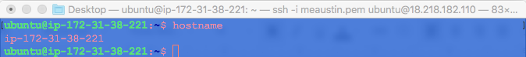
2. Type “ifconfig” in the shell and write down the MAC address of the instance. **(10 points)**
   1. fe80::8ca:c4ff:fed1:2d92/64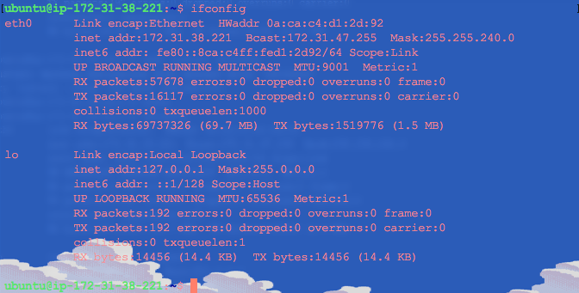
3. Type “pwd” in the shell and write down the current working directory. **(10 points)**
   1. /home/ubuntu
   2. 
4. Type “ps” in the shell and show the result with a screenshot. **(10 points)**
   1. 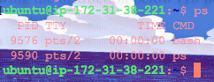
5. Create a directory named “Assignment1” on the \home\ubuntu\ directory by following the instruction below **(10 points)**
   1. $mkdir Assignment1
      1. 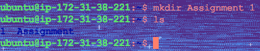
6. Go to the “Assignment1” directory and create a file named “assignment1_demo.pdf” by following the instruction below. **(10 points)**
   1. $cd Assignment1
   2. $touch assignment1_demo.pdf
   3. 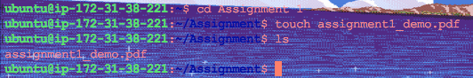
7. Go to the \home\ubuntu\ directory and remove the assignment1_demo.pdf file from the \home\ubuntu\ directory by using the ***rm*** command. **(10 points)**
   1. 